sEQUENTIAL – 6 classes - in 0.1091005802154541

pipChangeErG: 190063.86398082398

slopeErG: 237.1889855789071

varianceErG: 0.003614532216430099

BIRCH –10 classes – in 3.87078595161438

pipChangeErG: 51581.75753935189

slopeErG: 132.64789821537298

varianceErG: 0.0022729519841908634

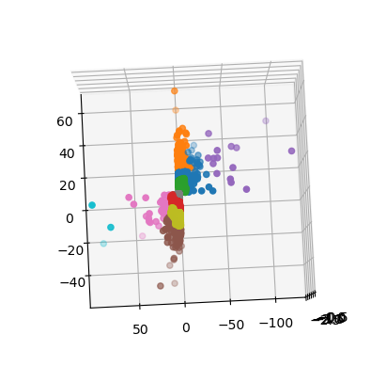

AffinityPropagation

ELIMINATED, TAKES TOO MUCH TIME

KMEANS – 10 classes – in 0.4068870544433594

pipChangeErG: 40921.81452015307

slopeErG: 134.1918574344003

varianceErG: 0.0022039453597330638

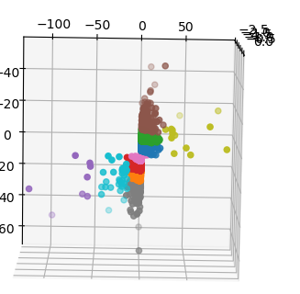

MiniBatchKMeans – 10 classes – in 0.1411290168762207

pipChangeErG: 35187.70412412244

slopeErG: 171.1960150893623

varianceErG: 0.002095945386030505

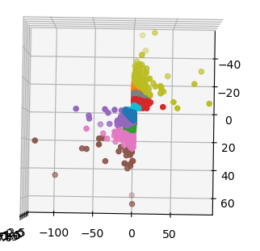

GaussianMixture – 10 classes – in 0.42763590812683105

pipChangeErG: 74941.98965910135

slopeErG: 139.54908800610258

varianceErG: 0.002417070100473032

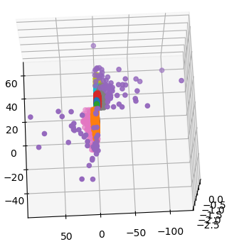weird visuals, intricated by the third dimension as well

Agglomerative Clustering – 10 classes - in 4.640515089035034

pipChangeErG: 42495.07021213796

slopeErG: 133.96199594560758

varianceErG: 0.0018788280131810317

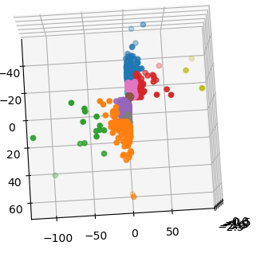

DBSCAN-120 classes – in 0.4819459915161133

pipChangeErG: 73767.25538462149

slopeErG: 191.4373128389427

varianceErG: 0.0028628246215235582

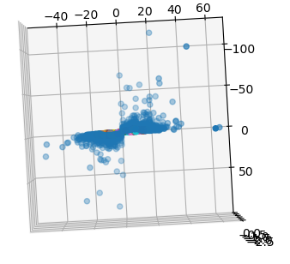needs tweaking

MeanShift -27 classes – in 140.30815052986145

pipChangeErG: 5244.340627479895

slopeErG: 27.818241866972706

varianceErG: 0.0005478169474255563

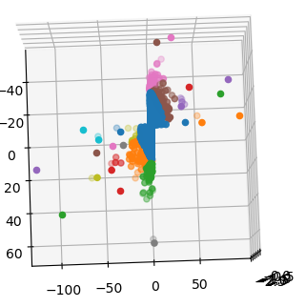very weird results

Semi-ELIMINATED, TAKES TOO MUCH TIME

OPTICS -338 classes - in 16.090538263320923

pipChangeErG: 126194.88753941271

slopeErG: 187.56380931855793

varianceErG: 0.0035804507563009383

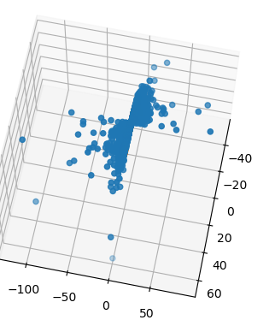bad segmentation

SpectralClustering – 2 classes

pipChangeErG: 0.0

slopeErG: 0.0

varianceErG: 0.0

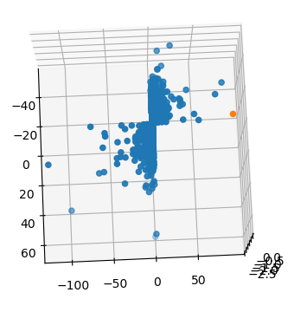bad cluster

Semi-ELIMINATED, TAKES TOO MUCH TIME

FINAL 3

Birch

Kmeans

MiniBatch

Begin Birch algorithm

Created clases: 10

pipChangeErG: 72203.72017123559

slopeErG: 163.51567136278956

varianceErG: 0.0026623665341273923

End algorithm:Birch in 3.2851486206054688

_____

Begin KMeans algorithm

Created clases: 10

pipChangeErG: 37729.5911562245

slopeErG: 144.72256826003866

varianceErG: 0.0020602311606738575

End algorithm:KMeans in 1.423814296722412

_____

Begin MiniBatchKMeans algorithm

Created clases: 10

pipChangeErG: 43914.29776424244

slopeErG: 140.0589417232441

varianceErG: 0.0024231096655818233

End algorithm:MiniBatchKMeans in 1.02089524269104

End STAGE 3: Elapsed time:5.858979225158691

Begin Birch algorithm

Created clases: 10

pipChangeErG: 81247.180308554

slopeErG: 136.98492174923112

varianceErG: 0.002322364492243926

End algorithm:Birch in 7.819602012634277

_____

Begin KMeans algorithm

Created clases: 10

pipChangeErG: 38977.8571860777

slopeErG: 146.7533674897905

varianceErG: 0.0020613815874410417

End algorithm:KMeans in 4.516047954559326

_____

Begin MiniBatchKMeans algorithm

Created clases: 10

pipChangeErG: 38953.31085439897

slopeErG: 153.74962745437122

varianceErG: 0.002376561239189403

End algorithm:MiniBatchKMeans in 4.950520277023315

End STAGE 3: Elapsed time:17.423295736312866